**5**

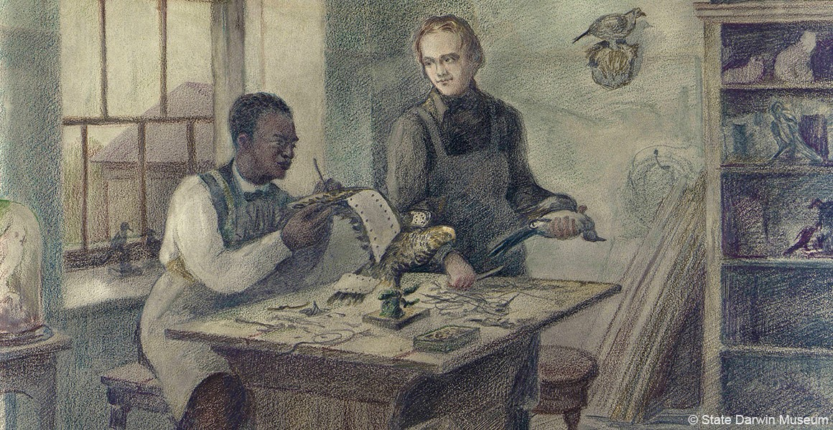

John Edmonstone was enslaved on a timber plantation in Demerara (now part of Guyana), South America, owned by Scotsman [Charles Edmonstone](https://www.spanglefish.com/slavesandhighlanders/index.asp?pageid=222592) (hence John's surname - his birth name remains unknown).

Plantation owner Charles Edmonstone returned to Scotland in 1817 and John came with him. Although we don't know if John was already free when he arrived, he would have become a free man on entering Scotland. Owning slaves was banned in Scotland in 1778 following the case of [James Knight.](https://www.blackhistorymonth.org.uk/article/section/history-of-slavery/scotland-and-slavery/)

At first, John lived in Glasgow. By 1824 he was in Edinburgh, making a living for himself working for the University of Edinburgh's zoological museum and living at 37 Lothian Street.

Darwin went to Edinburgh in 1825 when he was 16. Edmonstone charged Darwin one guinea for an hour every day for two months, teaching Darwin taxidermy. As well as the time spent on instruction, the two must have conversed on the natural history Edmonstone knew first-hand from South America.

Source: <https://www.nhm.ac.uk/discover/john-edmonstone-the-man-who-taught-darwin-taxidermy.html>

**9.**

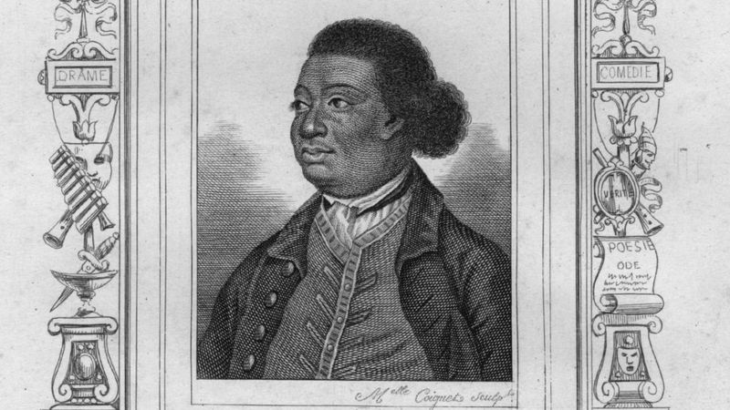

Ignatius Sancho was a very influential figure in the arts. He was born on a slave ship and was brought to England by his owner as an orphan, where he worked as a butler.

However, the man whom he worked saw how clever he was and supported his creativity, Sancho wrote plays, poetry and music, and eventually ended up setting up his own shop in London, where other creative people like him could meet up.

He used his ability to read and write to soeak out against the slave trade too.

Aside from his creativity, he is also the first known black British **voter.**  Black people didn’t use to be able to vote when white people could, because they were not treated the same. Source: <https://www.bbc.co.uk/newsround/41775249>

**7.** Moments in History . Timeline

1913 - John Archer becomes the first black mayor of London.

1914-1918 - The First World War brings an influx of people from different countries around the world.

1939-1945 - People from the Caribbean and West Africa arrive as wartime workers and servicemen in the army, navy and air force.

1950s-1960s - There is a huge migration of people from all over the Caribbean to work in hospitals and on transport and railway networks. They often struggle with racial prejudice.

1968 - Many Asian people are expelled from Kenya and settle in Britain.

1976 - **The Race Relations Act is passed and the Commission** for Racial Equality is established. British Asian people from Malawi settle in Britain.

1980s - Somali refugees arrive in Britain.

1987 - The first black members of parliament are elected.

1993 - The Asylum and Immigration Appeals Act is passed.

2001 - The Race Relations Amendment Act states all public services must actively promote racial equality.

2006 - The Racial and Religious Hatred Act makes it illegal to stir up hatred against someone because of their race or religion.

2011 - 1,904,684 people (3% of the population) record they were 'Black, African, Caribbean or Black British' in the UK census.

Source: [https://www.spelthorne.gov.uk/article/19678/A-timeline-of-black-history-in-Britain#:~:text=1792%2D1815%20%2D%20Black%20soldiers%20and,formed%20in%20Liverpool%20and%20Cardiff](https://www.spelthorne.gov.uk/article/19678/A-timeline-of-black-history-in-Britain" \l ":~:text=1792%2D1815%20%2D%20Black%20soldiers%20and,formed%20in%20Liverpool%20and%20Cardiff).