**5**

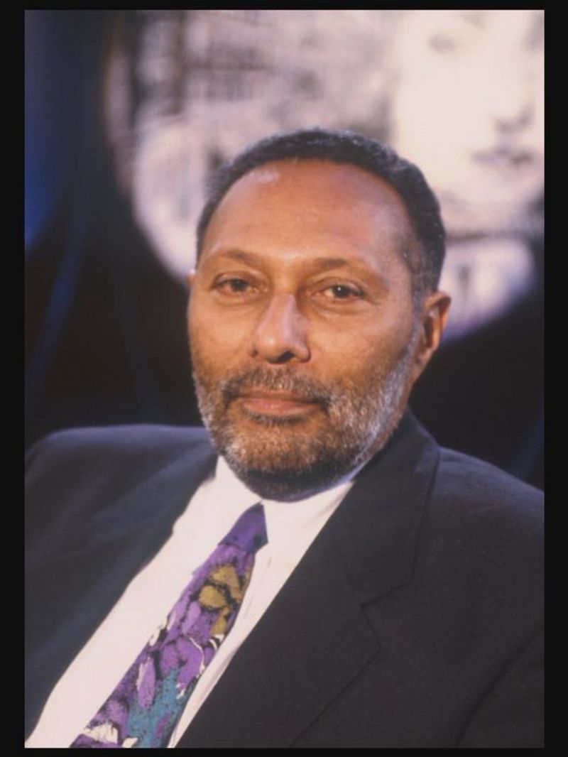

Stuart Hall is known as an important figure for multiculturalism. This is the bringing together of different cultures- the people, the ideas and the traditions.

He came to Britain, from Jamaica in the 1950s and became an important figure encouraging the study of many issues that affect people and polictics- for example issues about race, sexuality, and how people feel about themselves.

He went on to be responsible for the first cultural studies course in Britain, which was offered by the University of Birmingham.

Source: <https://www.bbc.co.uk/newsround/41775249>

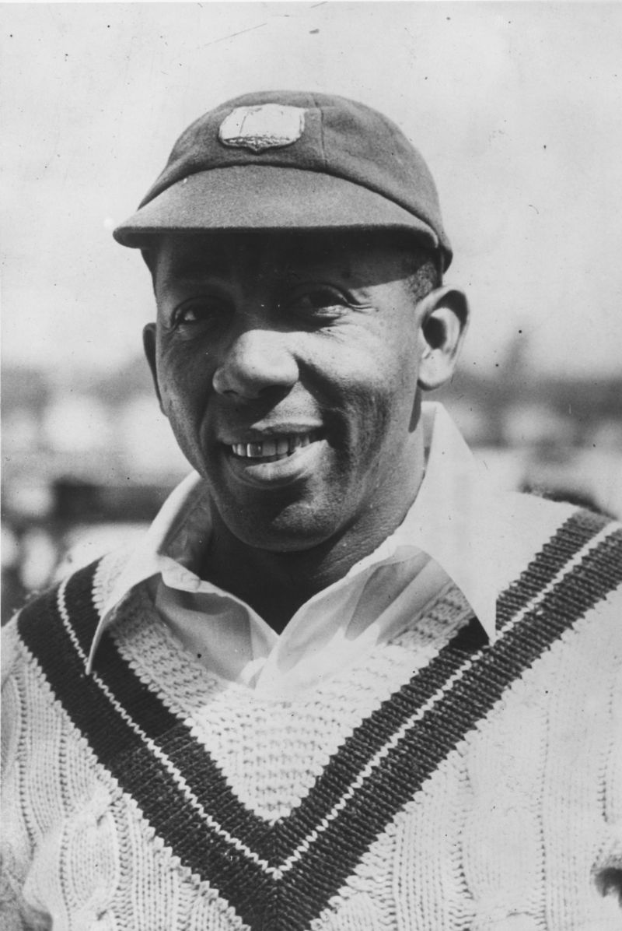

**6**

Born in Trinidad, Learie Constantine would go on to become England’s first black peer because of the work that he did for politics and racial equality.

This means he was allowed to sit in the House of Lords and take part in important political debates.

He was also a well-known cricket player.

He settled in Britan in a town in Lancashire called Nelson after he played cricket there for the West Indies in 1928. It caused a bit of a stid, as people were not used to seeing black people around. Source: <https://www.bbc.co.uk/newsround/41775249>

**8**

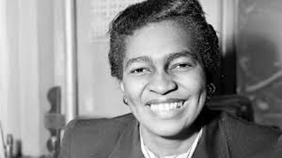

When violent riots broke out in Notting Hill in 1958, Claudia Jones worked ‘to wash the taste of the riots from the mouths of Black people’. In an attempt to uplift Black British communities, she helped to launch the **Notting Hill Carnival** in 1959. The first carnival took place at St Pancras Town Hall. Televised by the BBC, it was a celebration of West Indian culture and heritage. Today, Notting Hill carnival is the second largest street gathering in the world. It is a meeting place for artists, activists and crowds that are eager to display unity and enjoy music, dance, calypso, steel drums, masquerade, and food stalls.

http://www.bristol.ac.uk/history/public-engagement/blackhistory/snapshots/claudiajones/