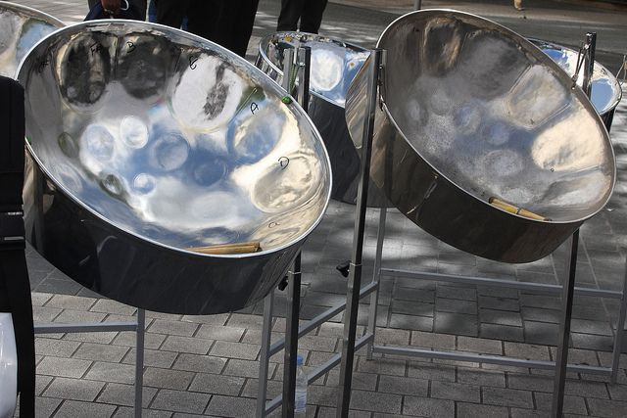**2**

The steel pan (also known as steel drums, or ‘pan’) was created in Trinidad and Tobago in the 1930s. It was established in contexts of Carnival resistance, its history being traced back to the enslaved Africans who were brought to the Caribbean in the 1700s.

https://artsandculture.google.com/story/the-origins-of-steel-pan-notting-hill-carnival/AAWBxQd4TKb21w?hl=en

**Music 2.**

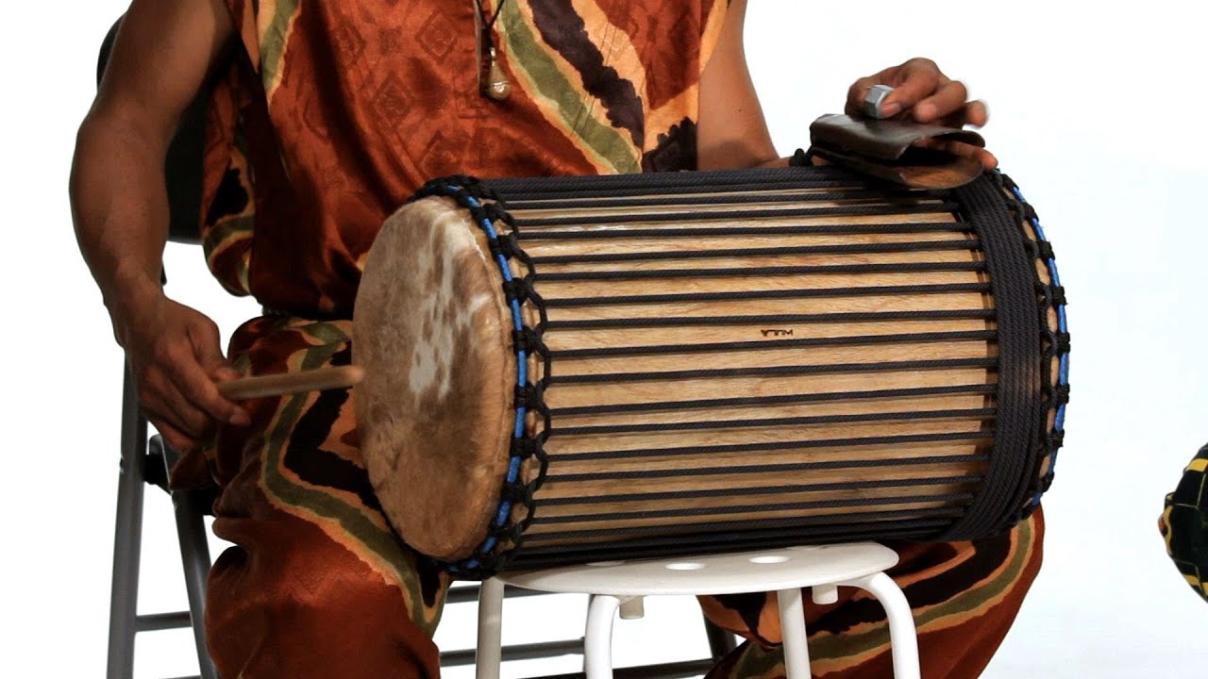

The West African instrument dùndún is also known as “talking drum” because players can match the pitch and rhythm of speech patterns on it.

With origins in the **Ghana Empire** between the 7th and 13th centuries, the talking drum is one of the oldest instruments in West Africa, not to mention, one of the oldest instruments still in use today.

Later, talking drums were used as a means of inter-village communication themselves rather than accompaniment. Instead of hand delivering a summons or warning from one village to another, a message could be sent directly via drum. Players were taught the corresponding drum phrase for any given word. Messages would then be sent between drum players beginning with the name of the recipient, followed by the name of the sender, and then finally the message.

West African talking drums remain popular in the region today, especially in the Senegalese Mbalax music style, and have even found their way into popular culture elsewhere in the world, being featured by artists such as Fleetwood Mac, Erykah Badu, Tom Waits and The Grateful Dead. <https://www.archaicroots.com/drums/talking-drums-ancient-storytellers-west-africa/>

**Music 3.**

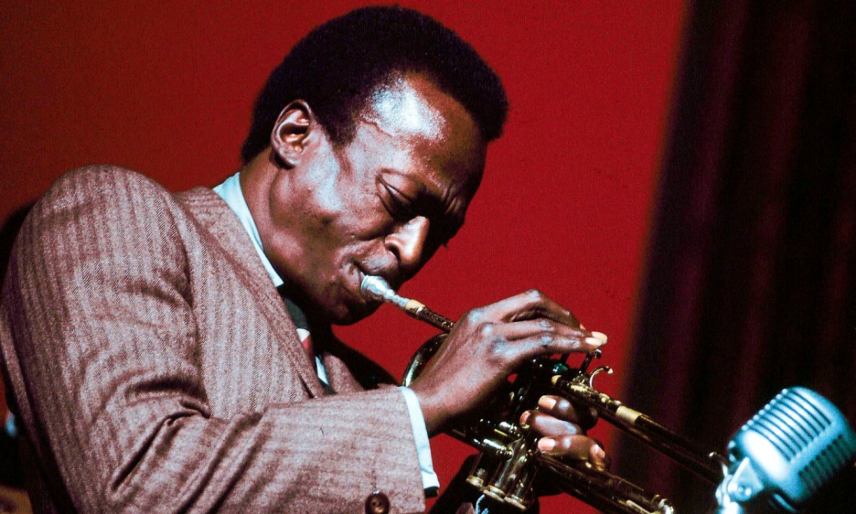

Miles Davis (1926- 1991)

Created at the end of the 19th century, blues music is a style of music that is heavily influence by African American history. The original blues music evolved and grew into jazz from the 1920s.

[The Saxophone](https://jazzfuel.com/jazz-instruments/saxophone)

Perhaps the most iconic jazz instrument of all time, the saxophone has been a consistent in jazz through its history, adapting to the different styles that have emerged in it’s history.

### [The Trumpet](https://jazzfuel.com/jazz-instruments/trumpet)

The trumpet was the first jazz instrument, made famous by the original [jazz superstar Louis Armstrong](https://jazzfuel.com/louis-armstrong/).

#### **Piano**

The piano is a flexible instrument that seems to appear in many genres of music across the globe. The flexibility of the instrument makes it a great choice for jazz.

#### **The Drums**

The drums have always been part of jazz, because the beat and sound of the drums is so integral to the cultural history of where jazz music originated and evolved from. The drums are essentially the rhythm section of the jazz ensemble, and includes the bass drum, snare drum and cymbals.